Page Level Security in Power BI

Data security and access control are critical considerations when sharing dashboards and reports in Power BI. While Row Level Security (RLS) allows for granular control at the row level, Page Level Security takes it a step further by restricting access to specific pages within a report.

Page-level security in Power BI involves limiting access to specific report pages, ensuring users only see content relevant to their role. If you want to control the access to the Power BI report pages (or tabs) in a way that some users see some pages, and some others see other pages, we need something called page-level security. While Power BI doesn't provide built-in support for page-level security like it does for row-level security (RLS), you can implement it using alternative methods and workarounds.

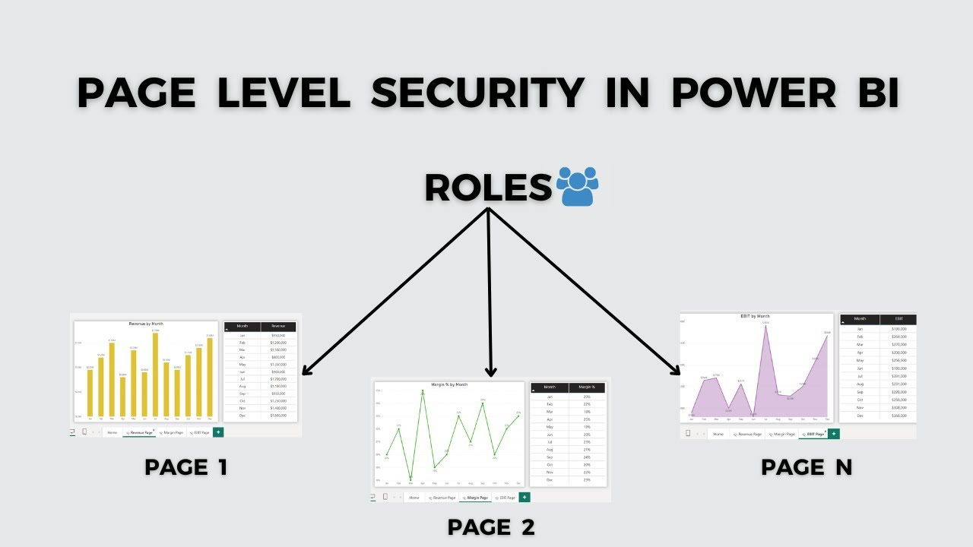

Steps to implement PLS:

**Step 1: Creating the Page Table and Assigning Index**

**Step 2: Creating Columns for Page Access**

**Step 3: Setting up the Slicer and Page Navigation**

**Step 4: Creating Roles**

**Step 5: Adding Page Filters to the Role**

**Step 6: Modifying the Filter Value to ‘True’ and Save**

**Step 7: Viewing the Dashboard from the Role’s Perspective**

Advantages:

1. **Enhanced User Experience**: Users only see the content relevant to them, providing a cleaner and more focused interface.
2. **Customized Reports**: Tailors report pages to specific roles or departments, ensuring users access the pages that meet their needs without unnecessary distractions.
3. **Improved Data Confidentiality**: Restricts access to sensitive information by limiting visibility to specific pages, adding a layer of privacy for different user groups.
4. **Scalability**: Easily adaptable for large organizations with diverse user roles, enabling efficient access control across multiple users.
5. **Optimized Performance**: Limits unnecessary processing or data retrieval by showing users only the pages they are authorized to view, which can improve report performance.

Limitations:

1. **No Native Support**: Power BI doesn’t provide built-in functionality for page-level security like it does for row-level security (RLS), requiring manual workarounds.
2. **Inconsistent Drillthrough Behavior**: Drillthrough features may not work seamlessly with page-level security workarounds, as users could unintentionally access restricted pages.
3. **Not Foolproof for Security**: Pages can still be accessed if users know the direct page link, as workarounds rely on navigation barriers rather than actual security restrictions.
4. **Performance Impact**: Using visual-level filters or dynamic navigation based on conditions may cause performance degradation, especially with large datasets.
5. **Scalability Issues**: As the number of users and roles increases, maintaining separate navigation paths or reports becomes increasingly challenging and harder to scale.